**BIKE SALES QUERIES**

**KPI’S**

**1. Total ORDER**

SELECT COUNT(DISTINCT Order_Id) AS Total_Order

FROM Bike_Sales

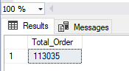

**2. TOTAL QUANTITY ORDER**

SELECT SUM(Order_Quantity) AS Total_Quantity_Order

FROM Bike_Sales

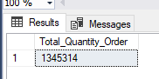

**3. TOTAL COST**

SELECT SUM(Cost) AS Total_Cost

FROM Bike_Sales

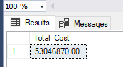

**4. TOTAL REVENUE**

SELECT sum(Revenue) AS Total_Revenue

FROM Bike_Sales

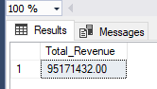

**5. TOTAL PROFIT**

SELECT SUM(profit) AS Total_Profit

FROM Bike_Sales

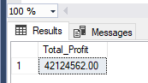

**6. DAILY TREND FOR TOTAL REVENUE**

SELECT DATENAME(DW,Date) AS Order_Day, sum(Revenue)AS Total_Revenue

FROM Bike_Sales

GROUP BY DATENAME(DW,Date)

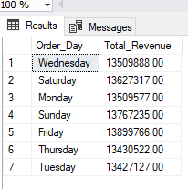

**7. MONTHLY TREND FOR TOTAL REVENUE**

SELECT DATENAME(MONTH,Date) AS Order_Day, sum(Revenue)AS Total_Revenue

FROM Bike_Sales

GROUP BY DATENAME(MONTH,Date)

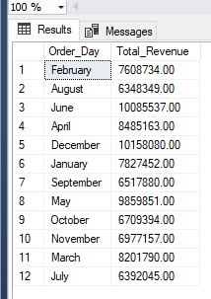

**8. YEARLY TREND FOR TOTAL REVENUE**

SELECT DATENAME(YEAR,Date) AS Order_Day, sum(Revenue)AS Total_Revenue

FROM Bike_Sales

GROUP BY DATENAME(YEAR,Date)

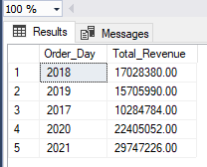

**9. PRODUCT CATEGORY BY TORAL QUANTITY SOLD**

SELECT Product_Category, SUM(Order_Quantity) AS Total_Quantity_Sold

FROM Bike_Sales

GROUP BY Product_Category

ORDER BY Total_Quantity_Sold

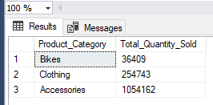

**10. REVENUE AND PROFIT BY COUNTRY**

SELECT Country, SUM(Revenue) AS Total_Revenue, SUM(Profit) AS Total_Pofit

FROM Bike_Sales

GROUP BY Country

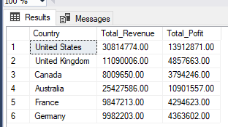

**11. REVENUE AND PROFIT BY STATE**

SELECT State, SUM(Revenue) AS Total_Revenue, SUM(Profit) AS Total_Pofit

FROM Bike_Sales

GROUP BY State

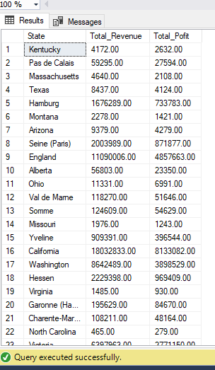

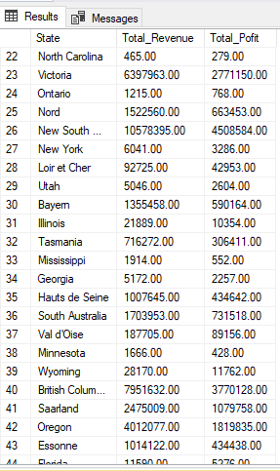

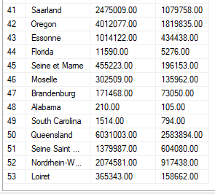

**12. REVENUE AND PROFIT OF PRODUCT CATEGORY**

SELECT Product_Category,SUM(Revenue) AS Total_Revenue, SUM(Profit) AS Total_Pofit

FROM Bike_Sales

GROUP BY Product_Category

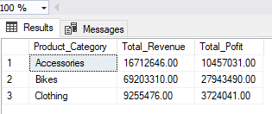

**13. REVENUE AND PROFIT BY AGE GROUP**

SELECT Age_Group,SUM(Revenue) AS Total_Revenue, SUM(Profit) AS Total_Pofit

FROM Bike_Sales

GROUP BY Age_Group

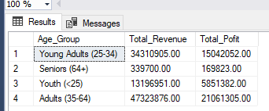

**14. TOTAL QUANTITY ORDER BY CUSTOMER GENDER**

SELECT Customer_Gender, Sum(Order_Quantity) AS Total_Quantity_Order

FROM Bike_Sales

Group by Customer_Gender

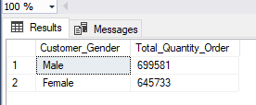

15. PROFITS AND REVENUE BY CUSTOMER GENDER

SELECT Customer_Gender, Sum(Profit) AS Total_Profit, SUM(Revenue)AS Total_Revenue

FROM Bike_Sales

Group by Customer_Gender

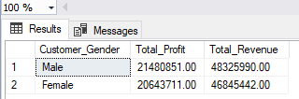

16. % OF PRODUCT CATEGORY BY REVENUE

SELECT Product_Category, CAST(SUM(Revenue) * 100.0 /(SELECT SUM(Revenue) FROM Bike_Sales

)AS DECIMAL(10,2)) AS Percentage

FROM Bike_Sales

GROUP BY Product_Category

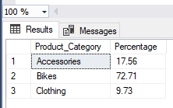

17 % OF PRODUCT CATEGOERY PROFIT

SELECT Product_Category, CAST(SUM(Profit) * 100.0 /(SELECT SUM(Profit) FROM Bike_Sales

)AS DECIMAL(10,2)) AS Percentage

FROM Bike_Sales

GROUP BY Product_Category

